National University of Computer and Emerging Sciences Chiniot-Faisalabad Campus



**metabase**

Software Quality Engineering

### Semester Project

### Phase 2

### BS (SE) 5A

## Team Name: zzwave-testing

## Team Member’s:

## 21F-9516 -> Suresh Kumar

## 21F-9519 -> Rai umer farooq

## 21f-9510 -> mian fahad akhtar

# **Automation Test Cases For GUI: -**

**Test case: Dashboard Loading**

**import** org.openqa.selenium.By;

**import** org.openqa.selenium.WebDriver;

**import** org.openqa.selenium.chrome.ChromeDriver;

**import** org.openqa.selenium.support.ui.WebDriverWait;

**import** org.openqa.selenium.support.ui.ExpectedConditions;

**public** **class** testcases {

**public** **static** **void** main(String[] args) {

System.*setProperty*("webdriver.chrome.driver", "

WebDriver driver = **new** ChromeDriver();

driver.manage().window().maximize();

driver.get("https://metabase.com");

**long** startTime = System.*currentTimeMillis*();

WebDriverWait wait = **new** WebDriverWait(driver, 15);

wait.until(ExpectedConditions.*visibilityOfElementLocated*(By.*className*("home-page")));

**long** endTime = System.*currentTimeMillis*();

**if** (endTime - startTime <= 5000) {

System.***out***.println("Dashboard loaded efficiently");

} **else** {

System.***out***.println("Dashboard did not load efficiently");

}

driver.quit();

}

}

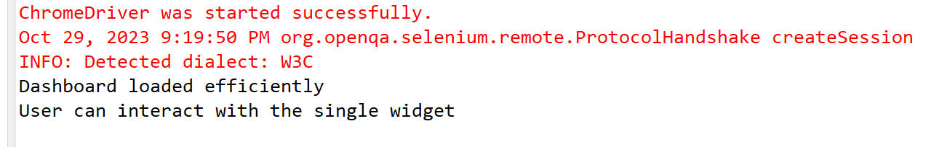

**Test case: Performance test With Minimal widget**

**import** org.openqa.selenium.By;

**import** org.openqa.selenium.WebDriver;

**import** org.openqa.selenium.chrome.ChromeDriver;

**import** org.openqa.selenium.support.ui.WebDriverWait;

**import** org.openqa.selenium.support.ui.ExpectedConditions;

**public** **class** testcases {

**public** **static** **void** main(String[] args) {

System.*setProperty*("webdriver.chrome.driver", "

WebDriver driver = **new** ChromeDriver();

driver.manage().window().maximize();

driver.get("https://metabase.com");

**long** startTime = System.*currentTimeMillis*();

WebDriverWait wait = **new** WebDriverWait(driver, 15);

wait.until(ExpectedConditions.*visibilityOfElementLocated*(By.*className*("home-page")));

**long** endTime = System.*currentTimeMillis*();

**if** (endTime - startTime <= 5000) {

System.***out***.println("Dashboard loaded efficiently");

} **else** {

System.***out***.println("Dashboard did not load efficiently");

}

**boolean** isWidgetInteractive = driver.findElement(By.*className*("align-items-center")).isEnabled();

**if** (isWidgetInteractive) {

System.***out***.println("User can interact with the single widget");

} **else** {

System.***out***.println("User cannot interact with the single widget");

}

driver.quit();

}

}



**Test case: Mobile Responsiveness Test**

**import** org.openqa.selenium.By;

**import** org.openqa.selenium.WebDriver;

**import** org.openqa.selenium.chrome.ChromeDriver;

**import** org.openqa.selenium.chrome.ChromeOptions;

**import** org.openqa.selenium.support.ui.WebDriverWait;

**import** org.openqa.selenium.support.ui.ExpectedConditions;

**public** **class** testcases {

**public** **static** **void** main(String[] args) {

System.*setProperty*("webdriver.chrome.driver", "

String[] devices = {"iPhone X", "Pixel 2", "Galaxy S5"};

**for** (String device : devices) {

ChromeOptions chromeOptions = **new** ChromeOptions();

chromeOptions.setExperimentalOption("mobileEmulation", **new** Object());

WebDriver driver = **new** ChromeDriver(chromeOptions);

driver.get("https://www.metabase.com");

WebDriverWait wait = **new** WebDriverWait(driver, 15);

wait.until(ExpectedConditions.*visibilityOfElementLocated*(By.*className*("home-page")));

**boolean** isDashboardLoaded = driver.findElements(By.*className*("home-page")).size() > 0;

**if** (isDashboardLoaded) {

System.***out***.println("Dashboard is user-friendly and interactive on " + device);

} **else** {

System.***out***.println("Dashboard is not user-friendly on " + device);

}

driver.quit();

}

}

}

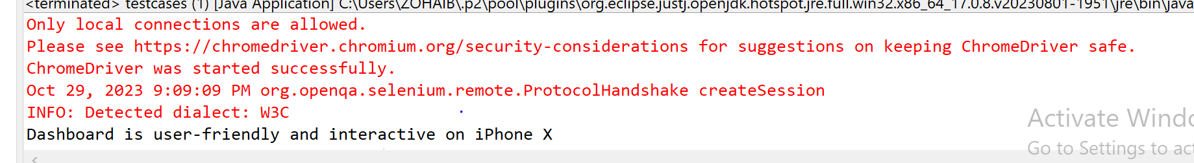

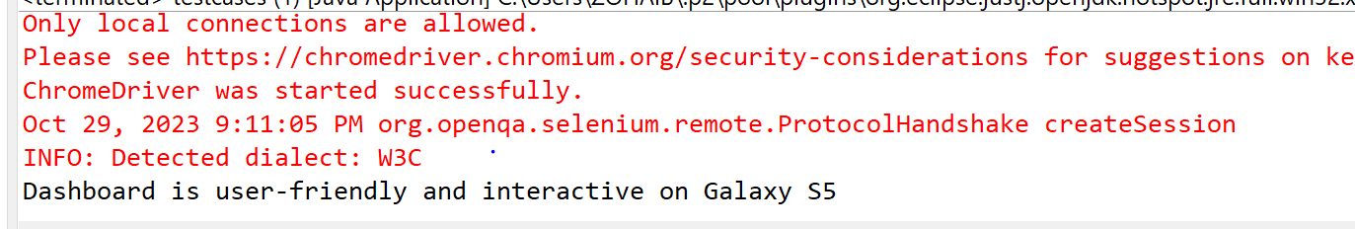

**Test case: Responsive Design Test**

**import** org.openqa.selenium.By;

**import** org.openqa.selenium.Dimension;

**import** org.openqa.selenium.WebDriver;

**import** org.openqa.selenium.chrome.ChromeDriver;

**import** org.openqa.selenium.support.ui.WebDriverWait;

**import** org.openqa.selenium.support.ui.ExpectedConditions;

**public** **class** testcases {

**public** **static** **void** main(String[] args) {

System.*setProperty*("webdriver.chrome.driver", "

WebDriver driver = **new** ChromeDriver();

Dimension[] resolutions = {

**new** Dimension(1920, 1080), // Full HD

**new** Dimension(1366, 768), // HD

**new** Dimension(1280, 1024) // Standard

};

**for** (Dimension resolution : resolutions) {

driver.manage().window().setSize(resolution);

driver.get("https://metabase.com");

WebDriverWait wait = **new** WebDriverWait(driver, 15);

wait.until(ExpectedConditions.*visibilityOfElementLocated*(By.*className*("home-page")));

**boolean** isDashboardLoaded = driver.findElements(By.*className*("home-page")).size() > 0;

**if** (isDashboardLoaded) {

System.***out***.println("Test successful for resolution: " + resolution.width + "x" + resolution.height);

} **else** {

System.***out***.println("Test failed for resolution: " + resolution.width + "x" + resolution.height);

}

}

driver.quit();

}

}

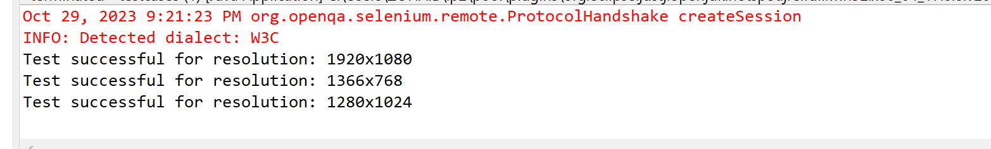

**Test case: Simultaneous User Access Test**

**import** java.util.concurrent.ExecutorService;

**import** java.util.concurrent.Executors;

**import** org.openqa.selenium.By;

**import** org.openqa.selenium.WebDriver;

**import** org.openqa.selenium.chrome.ChromeDriver;

**public** **class** testcases {

**public** **static** **void** main(String[] args) {

System.*setProperty*("webdriver.chrome.driver", "

ExecutorService executorService = Executors.*newFixedThreadPool*(100); // 100 threads for 100 users

**for** (**int** i = 0; i < 5; i++) {

executorService.submit(() -> {

WebDriver driver = **new** ChromeDriver();

**try** {

driver.get("https://metabase.com");

**boolean** isDashboardLoaded = driver.findElements(By.*className*("home-page")).size() > 0;

**if** (isDashboardLoaded) {

System.***out***.println("Test successful");

} **else** {

System.***out***.println("Test failed ") ;

}

} **finally** {

driver.quit();

}

});

}

executorService.shutdown();

}

}

